Name: John Francis   
Date: 3/13/2023  
Professor: Shaun Gray

IP Addressing and Virtualization Concepts

**Write a paragraph** (minimum five college-level sentences) below that summarizes what was accomplished in this activity, what you learned by performing it and just as important, how you feel it will benefit you in your academic and professional career. (10 points)

enable IPv6 routing globally on the NYEDGE1 router. Assign the appropriate IP addresses to the corresponding interfaces as described in the IP addressing scheme. Examine the state of these interfaces. Configure and Verify IPv6 Global Unicast Address on the NYWAN1 router. These exercises will help me to learn how IPv6 is configured in both my academic and professional careers.

Copy and paste the required screenshots from the **IP Addressing and Virtualization Concepts** activity, Exercise 5 to 14, and answer the questions below.

**Exercise 6 – Task 1, Step 3:** Paste a screenshot after executing the show ipv6 interface brief command, showing that the addresses have been properly configured on the interfaces of device NYEDGE1. Make sure that your screenshot contains the required time/date stamp! (5 points)

**Exercise 7 – Task 1, Step 4:** Paste a screenshot showing the successful ping from NYWAN1 to device 2001:a:0:1::1. Make sure that your screenshot contains the required time/date stamp! (5 points)

**Exercise 8 – Task 1, Step 4:** Paste a screenshot after executing the show ipv6 interface brief command on NYWAN1, showing that the device has correctly obtained an address using SLAAC. Make sure that your screenshot contains the required time/date stamp! (5 points)

**Exercise 9 – Task 1, Step 2:** Paste a screenshot after executing the ***show ipv6 interface brief*** command, showing that the addresses have been properly configured on the interfaces of device NYWAN1. Make sure that your screenshot contains the required time/date stamp! (5 points)

**Exercise 11 – Task 1, Step 2:** Paste a screenshot after executing the ***show ipv6 interface gi0/1*** command, showing that the addresses have been properly configured on the interfaces of device NYWAN1. Make sure that your screenshot contains the required time/date stamp! (5 points)

**Question:** Write out the host portion of the address that was automatically generated for the interface. In your own words, provide a brief description of how the host portion of the address was created? [Hint: do a little Internet research on the EUI-64 process.] (10 points)

The Host portion is FE80 this is created by using the MAC address of an interface the first 64 bit is the reversed address, and the remaining bits are taken from the MAC address.

**Exercise 14 – Task 1, Step 2:** Paste a screenshot after executing the ***show ipv6 interface gi0/0*** command, showing that the addresses have been properly configured on the interfaces of device NYWAN1. Make sure that your screenshot contains the required time/date stamp! (5 points)

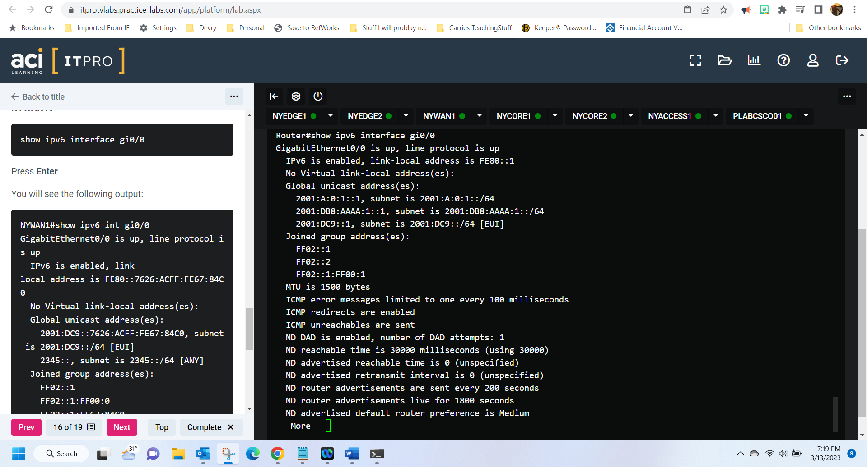

**Question:** Write out the host portion of the address that was automatically generated for the interface. In your own words, provide a brief description of how the host portion of the address was created? [Hint: do a little Internet research on the EUI-64 process.] (10 points)

The host portion of the address is FE80 the Extended Unique identifier helps to assign these IP addresses automatically. Like the link local, the Extended unique identifier can be generated using the MAC address.

**Congratulations! You are done with Module 3 graded practice activities!**